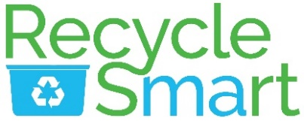
MassDEP Mattress and Textile Waste Bans

Background
Things are changing in Massachusetts! As of November 1, 2022, mattresses and textiles will no longer be allowed in the trash. New state rules require mattresses and textiles be kept out of the trash so they can be recycled or donated for reuse. In order to comply, Tolland will be changing/has changed the way we collect mattresses and textiles. Please see our website for instructions [Transfer Station & Recycling | Tolland MA (tolland-ma.gov)].
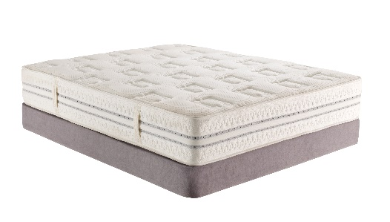
To help you understand these changes and the reasons behind them, the MassDEP has written a newsletter focusing on the new Waste Bans and why they are important. You can read the newsletter in its entirety here: Waste Bans 101: Less Trash for a Cleaner Mass…achusetts.
Background information
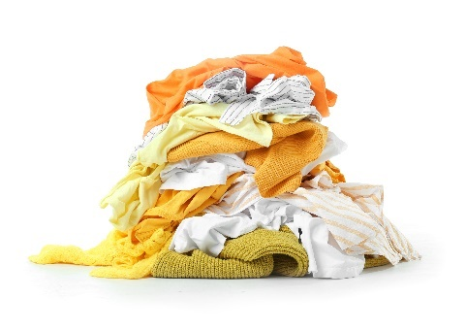
Why the change? The 2020 Solid Waste Master Plan has set a goal to reduce trash 30% by 2030 (from 5.7 million tons in 2018 to 4 million tons in 2030), and 90% by 2050. One of the strategies the State uses to achieve that goal is to exclude certain materials from the trash. This strategy is known as the “Waste Bans.”
What is a waste ban?
Massachusetts was one of the first states to implement a waste ban on easy-to-recycle and/or toxic materials. Things that are included in the list of materials banned from the trash are what the State considers too good or too bad for the trash. The waste bans were created to:
- Promote reuse, waste reduction, and recycling by keeping good stuff out of the trash
- Protect human health and the environment by keeping toxic stuff out of the trash
- Prolong the life of our landfills and incinerators while mitigating their environmental impacts
- Support local recycling and composting businesses by ensuring a reliable supply of materials
…all good things! The first MA waste ban went into effect on December 31, 1990, and prohibited lead acid batteries from landfill and incineration. Since then, MA has added several more items to the list.
Why Mattresses?
MA residents throw out 300,000 mattresses each year. That’s a lot of potential material that could be used to make new products. In fact, over 75% of mattress and box spring components can be easily disassembled and recycled.
Mattresses also take up a lot of space! Separating them for recycling is better for the planet and reduces the need for additional landfills and municipal waste combustion facilities.
What to do with your old mattress
If you’re not sure what to do with your old mattress, there are a few options to consider.
- You can donate mattresses in good condition (we recommend a quick Google search to find donation sites).
- You can give mattresses away via a local gifting group like Buy Nothing or Free cycle.
- If you are buying new, you can check with the retailer to see if they will recycle your old one.
- You can call a local junk hauler to take it away.

- And of course, you can recycle it. Tolland is in the process of making a mattress recycling facility available to Town residents. A notice will be sent to all Transfer Station users when this becomes available

Textile Recovery and Recycling

Did you know that residents and businesses dispose of approximately 230,000 tons of textiles annually?
More than 5% of the waste delivered to combustion facilities is made of clothing, curtains, towels, and other fabrics.
About 85% of the textiles currently being thrown away could be donated, reused, or recycled instead.
Textiles aren’t actually “recycled” in the way cans, bottles, and papers are. They must be separated and handled by organizations that know how to sort them for three types of use: resale as second-hand clothing; cutting into shop rags; and shredding into fiber for insulation, carpet padding, and soundproofing.
“Textiles” includes clothes, shoes, linens, towels, curtains, and cloth accessories, bags, belts, hats, and more. When in doubt, check the Recyclopedia. This can be found on the Town website under the Transfer Station Tab.
Contrary to popular belief, donations in any condition are welcomed by most for-profit and nonprofit textile collectors alike. This includes stains, rips, missing buttons or broken zippers. The only unacceptable donations are wet/moldy items and items contaminated with oil or hazardous substances. Items that don't sell in thrift stores are baled and sold to brokers or graders who sell to overseas markets. In developing nations, used clothing and textiles supply local enterprises with materials to repair and resell. Other textiles can be converted to their original fibers and manufactured into other materials, such as wiping cloths or insulation.
​
​ Textiles should never go in your household recycling bin. They also do not belong in the trash, unless they are wet, moldy, or contaminated.

There are many paths your used textiles can take:
- Donated textiles can be given or resold to people who need them here in the US and abroad.
- Textiles in poor condition can become industrial wiping cloths, aka "shop rags".
- Anything that cannot be resold can be remanufactured into insulation used by a variety of industries (e.g., automotive, home furnishings, and carpet padding).
- Drop off textiles at designated collection bins or donate them to your favorite charity or thrift store. Donation bins accept the widest range of items; your local thrift store may be more restrictive in what they want. Some organizations will even pick up from your home. Go to Beyond the Bin for more information (Found on Town website).

The Town of Tolland is partnering with Big Brother Big Sister Foundation and CMRK to allow residents to easily donate clothing, textile and small household items. CMRK has been in operation for over 35 years.
Bins will be placed at Transfer Station and Town Hall and are available to residents of Tolland and surrounding Towns!
These collections divert clothing and house wares out of the landfill. You can schedule your free home pickup by visiting online. BBBS Foundation | Big Brother Big Sister Foundation.
Out with the old, in with the new- donate your gently used items - Homepage - DNCE (donatene.org)

For additional locations to recycle your unwanted textiles, search the MassDEP Beyond the Bin Recycling Directory found on the Town website under the Transfer Station and Recycling tab.

